**Assignment6.6**

**Question:** Write a map reduce program to use Sequence file as input and save the output in key value output format.

**Note:** You can use the sequence file output which you have got in the earlier assignment of the same session.

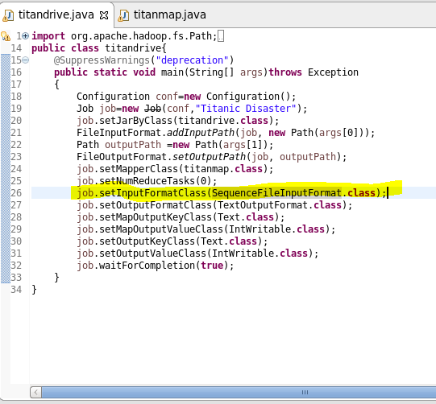

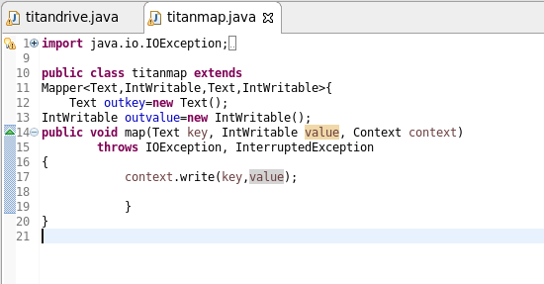

**Output:**

